WPM – More than 50(Normal Typing Test)

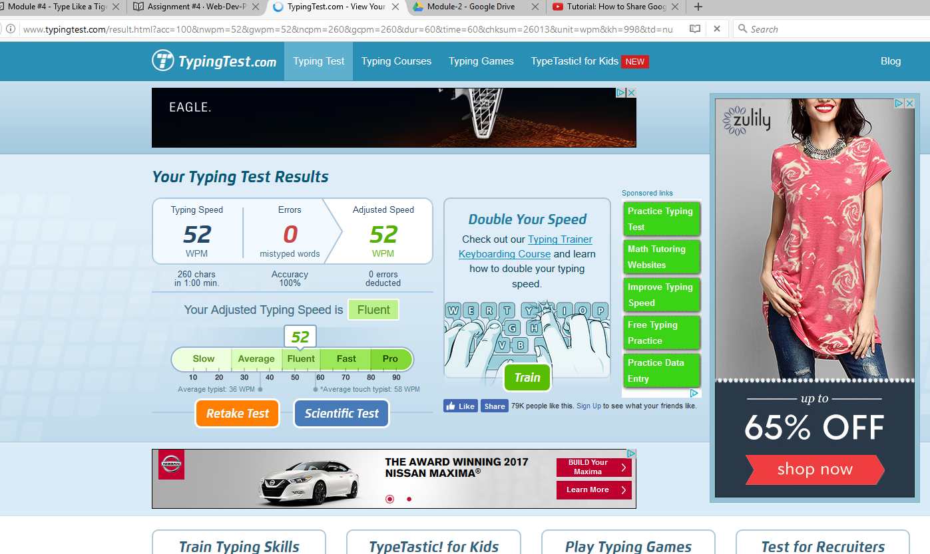

Javascript (coding) typing test

